Structure Chart — API Gateway

SC Figure 1.4.1.1

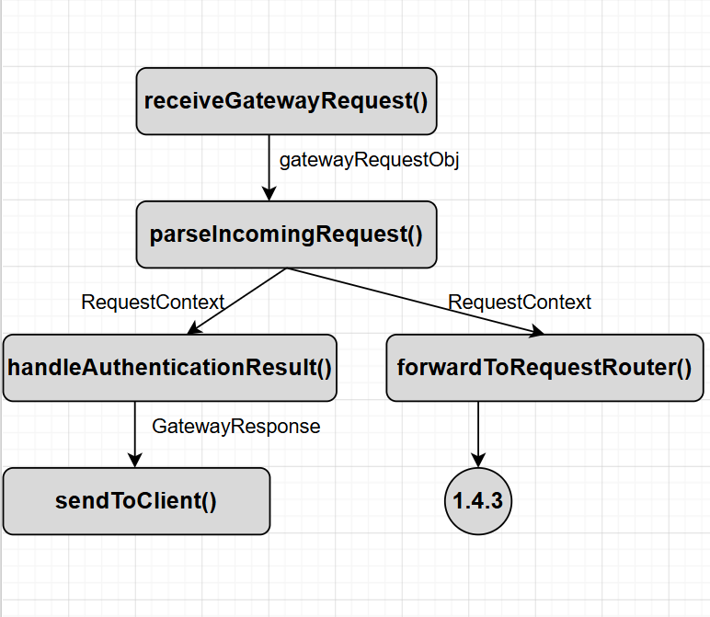

API Gateway Structure Chart View Design Information
Field | Description / Purpose
View Name & Number | 1.4.1.1 API Gateway Structure Chart View
Purpose / Design Concern | Manages User API Requests and verifies User Credentials
Description | Routes User API request results to either Authentication or back to the client for an appropriate gateway response.
Requirements
Elements
 | receiveGatewayRequest()
 | gatewayRequestObj
 | parseIncomingRequest()
 | RequestContext
 | handleAuthenticationResult()
 | forwardToRequestRouter()
 | GatewayResponse
 | sendToClient()
Inputs | Gateway Request
Outputs | Gateway Response, Request Context
Navigation / References | 1.4.2 Authentication Handler, 1.4.3 Request Router
Viewpoint | Structure Chart View

Structure Chart — Authentication Handler

SC Figure 1.4.2.1

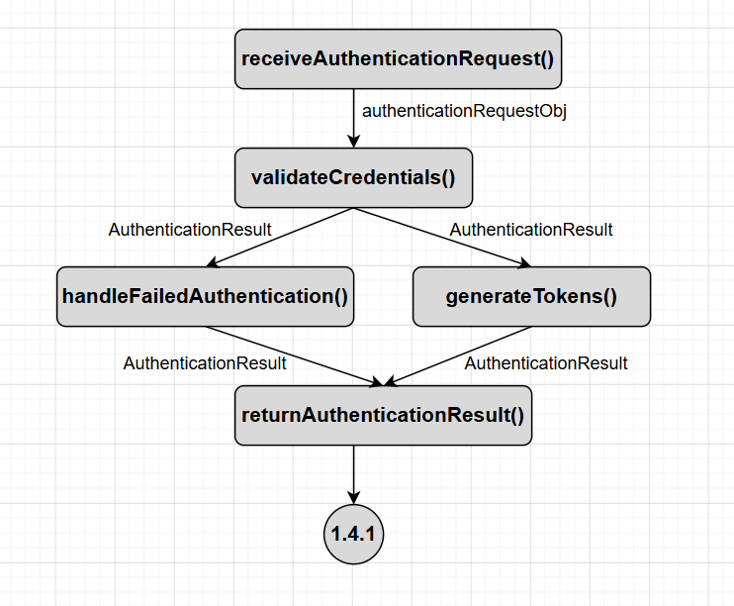

Authentication Handler Structure Chart View Design Information
Field | Description / Purpose
View Name & Number | 1.4.2.1 API Gateway Structure Chart View
Purpose / Design Concern | Verifies User Credentials and passes verification results to the API Gateway.
Description | Receives entered User Credentials and compares them to the users respective Credentials in an authentication database. Generates tokens upon successful verification. Returns results to the API Gateway
Requirements
Elements
 | receiveAuthenticationRequest()
 | authenticationRequestObj
 | validateCredentials()
 | AuthenticationResult
 | handleFailedAuthentication()
 | generateTokens()
 | returnAuthenticationResult()
Inputs | Authentication Request
Outputs | AuthenticationResult
Navigation / References | 1.4.1 API Gateway
Viewpoint | Structure Chart View

Structure Chart — Request Router

SC Figure 1.4.3.1

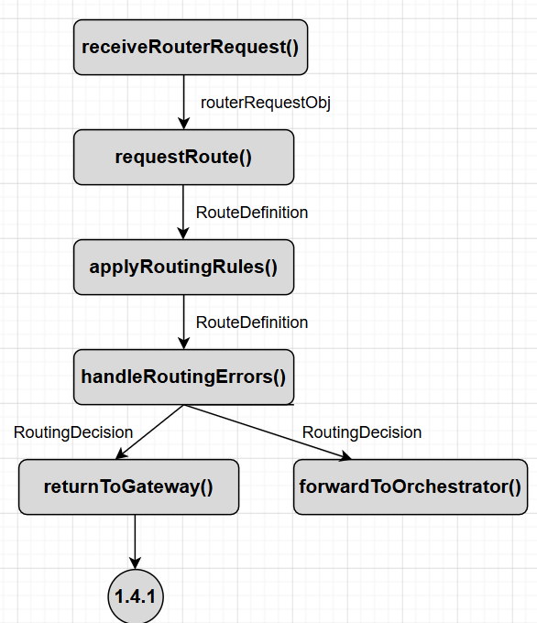

Request Router Structure Chart View Design Information
Field | Description / Purpose
View Name & Number | 1.4.3.1 API Gateway Structure Chart View
Purpose / Design Concern | Receives Routing Requests and forwards them to their intended destination.
Description | Receives entered Routing Request and applies routing rules to the request’s Routing Definition. A Routing Decision is then made and the request is sent to its intended destination.
Requirements
Elements
 | receiveRouterRequest()
 | routerRequestObj
 | applyRoutingRules()
 | RouteDefinition
 | handleRoutingErrors()
 | RoutingDecision
 | returnToGateway()
 | forwardToOrchestrator()
Inputs | RouterRequest
Outputs | RoutingDecision, routerRequestObj
Navigation / References | 1.4.1 API Gateway
Viewpoint | Structure Chart View

Data Flow Diagrams — API Gateway

DFD Figure 1.4.1.0.1 — Primary Workflow
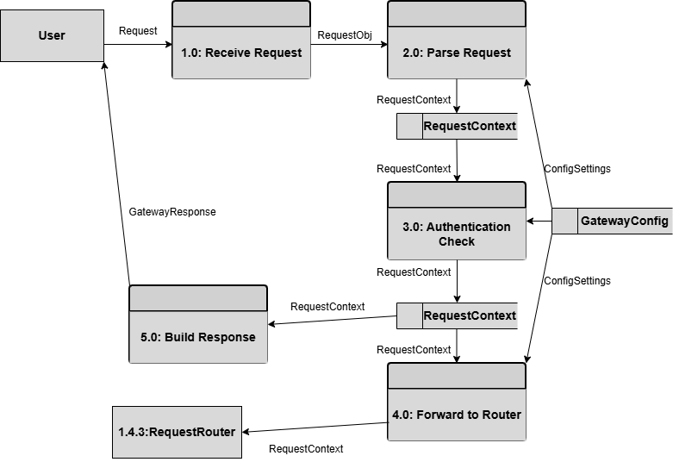

API Gateway DFD View Design Information
Field | Description / Purpose
View Name & Number | 1.4.1.0.1 API Gateway DFD View
Purpose / Design Concern | Manages User API Requests and verifies User Credentials
Description | Routes User API request results to either Authentication or back to the client for an appropriate gateway response.
Requirements
Elements
 | 1.0 Receive Request
 | gatewayRequestObj
 | 2.0 Parse Request
 | RequestContext
 | 3.0 Authentication Check
 | 4.0 Forward To Router
 | GatewayResponse
 | 5.0 Build Response
 | 1.4.3 Request Router
Inputs | Gateway Request
Outputs | Gateway Response, Request Context
Navigation / References | 1.4.2 Authentication Handler, 1.4.3 Request Router
Viewpoint | DFD View

Data Flow Diagrams — Authentication Handler

DFD Figure 1.4.2.0.1 — Primary Workflow
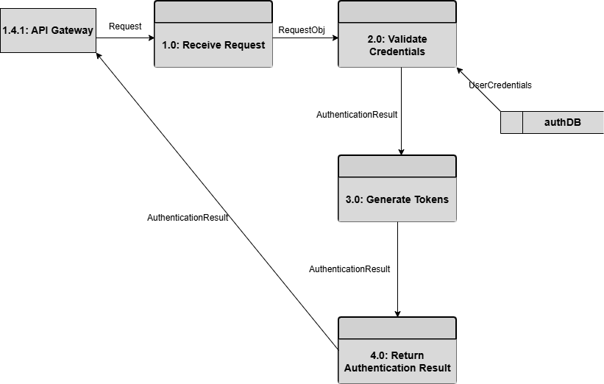

Authentication Handler DFD View Design Information
Field | Description / Purpose
View Name & Number | 1.4.2.0.1 API Gateway DFD View
Purpose / Design Concern | Verifies User Credentials and passes verification results to the API Gateway.
Description | Receives entered User Credentials and compares them to the users respective Credentials in an authentication database. Generates tokens upon successful verification. Returns results to the API Gateway
Requirements
Elements
 | 1.0 Receive Request
 | RequestObj
 | 2.0 Validate Credentials
 | AuthenticationResult
 | UserCredentials
 | 3.0 Generate Tokens
 | 4.0 Return Authentication Result
Inputs | Authentication Request
Outputs | AuthenticationResult
Navigation / References | 1.4.1 API Gateway
Viewpoint | DFD View

Data Flow Diagrams — Request Router

DFD Figure 1.4.3.0.1 — Primary Workflow
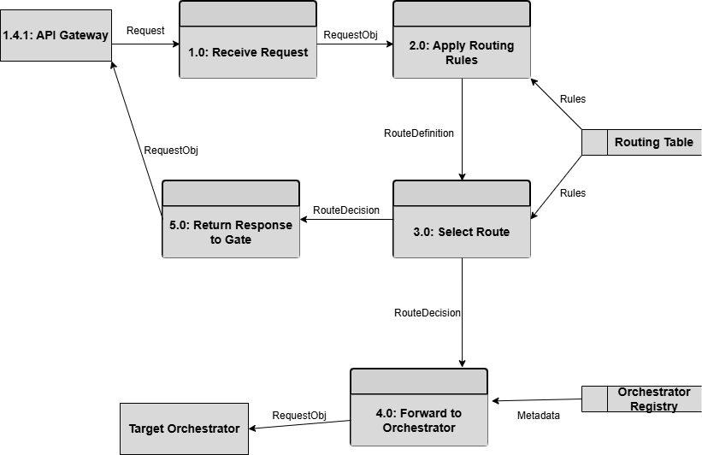

Request Router DFD View Design Information
Field | Description / Purpose
View Name & Number | 1.4.3.0.1 API Gateway DFD View
Purpose / Design Concern | Receives Routing Requests and forwards them to their intended destination.
Description | Receives entered Routing Request and applies routing rules to the request’s Routing Definition. A Routing Decision is then made and the request is sent to its intended destination.
Requirements
Elements
 | 1.0 Receive Request
 | RequestObj
 | 2.0 Apply Routing Rules
 | RouteDefinition
 | 3.0 Select Route
 | RoutingDecision
 | 5.0 Return To Gateway
 | 4.0 Forward To Orchestrator
 | Rules
 | Orchestrator Registery
 | Routing Table
Inputs | RouterRequest
Outputs | RoutingDecision, Request Obj
Navigation / References | 1.4.1 API Gateway
Viewpoint | DFD View

